**The ramdisk ‘tmp’ is full – VMware ESXi on HPE ProLiant**

We are using HPE ProLiant servers in our virtual environment to delivering different services to our customers. VMware ESXi has been installed on all servers as Hypervisor. You know that each vendor has customized image that includes VMware ESXi, drivers and management tools. It seems, there is an issue on HPE Agentless Management (AMS) on latest ESXi image.

**On This Post**  [Hide](https://www.teimouri.net/ramdisk-tmp-full-vmware-esxi-hpe-proliant/)

[1 What’s Exact Issue](https://www.teimouri.net/ramdisk-tmp-full-vmware-esxi-hpe-proliant/#Whats_Exact_Issue)

[1.1 Temporary Solution](https://www.teimouri.net/ramdisk-tmp-full-vmware-esxi-hpe-proliant/#Temporary_Solution)

[1.2 Permanent Solution](https://www.teimouri.net/ramdisk-tmp-full-vmware-esxi-hpe-proliant/#Permanent_Solution)

[2 Further Reading](https://www.teimouri.net/ramdisk-tmp-full-vmware-esxi-hpe-proliant/#Further_Reading)

[3 External Links](https://www.teimouri.net/ramdisk-tmp-full-vmware-esxi-hpe-proliant/#External_Links)

What’s Exact Issue

I saw lot of error messages on our ESXi server that all messages said /tmp is out of space:

Unlike other Unix-Like operating system, “df” command will show datastores status not system partitions. use “vdf” command to find useful information about system partitions.

[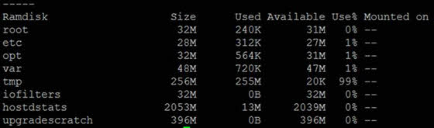](https://www.teimouri.net/wp-content/uploads/2019/05/ramdisk_tmp_full_esxi_1.jpg)

In my case, “ams-bbUsg.txt” was the root cause:

[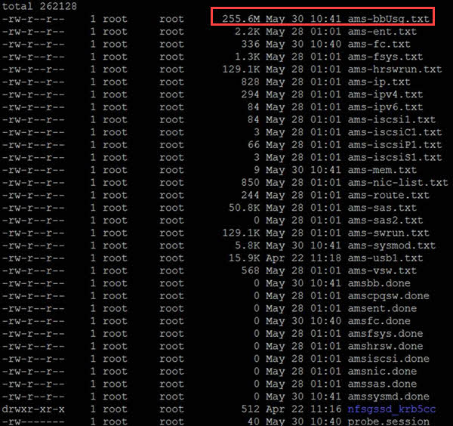](https://www.teimouri.net/wp-content/uploads/2019/05/ramdisk_tmp_full_esxi_2.jpg)

Temporary Solution

Removing the file is a temporary solution because, there is an issue on HPE AMS.

Permanent Solution

As describes in the below HPE advisory:

[**Advisory: VMware – VMware AMS Data File Filling Up Tmp May Cause VUM Updates to Fail On HPE Servers Running VMware ESXi 6.0/6.5/6.7 with AMS Version 11.4.0**](https://support.hpe.com/hpsc/doc/public/display?docId=emr_na-a00073323en_us&docLocale=en_US)

AMS should be updated 11.4.2.